Greetings South Broadview families,

In the blink of an eye, we are already at the winter break. We’ve had an excellent first part of the school year. It has been terrific having a more ‘normal’ rhythm again this fall.

As you know, we’ve had the ‘flu’ running through the school. Thank you to parents for keeping your kids home when they’re sick. I recognize how challenging this is when you’re trying to get to work yourself and worried about how much school they’re missing. I have never seen this flu hit students as hard as it has this year. Importantly, you should know that there are walk-in vaccination clinics up at the Field House this week for school-aged children. It’s not too late to consider a vaccine for your children against the flu.

Our very own “Mr Brett” (Brett Sherwood) was recently featured in the Salmon Arm Observer highlighting his incredible and generous Christmas Display. He spent hours and hours setting up the display to share with our South Broadview students and families. Please see the attached link: https://www.saobserver.net/community/i-like-to-share-christmas-with-people-village-displays-bring-joy-to-salmon-arm-school-students/
We are deeply thankful for this. The spirit of generosity is alive and well here at SBR. Thank you to the incredible generosity of families in our “12 Days of Caring” food drive. We have collected a lot of food and will distribute it to needy families within our community this week. Thank you as well for the generous donations via our hot lunch program. There is so much kindness within our community.

I hope you all have a lovely winter break together and have time to enjoy each other. We look forward to seeing everyone in the New Year. Please take a peek at our calendar on our website to keep up to date with the month-month schedule.

Warmly,

Heather Gobbett
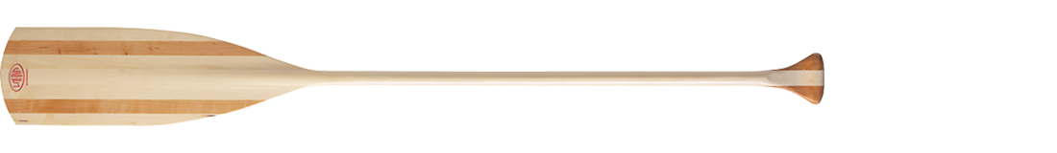

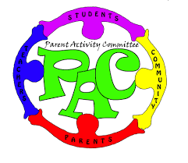
Parent Advisory Committee (PAC):

On behalf of the PAC members, I’d like to thank everyone for coming out and participating in our recent family games night and movie night. Keep an eye on our South Broadview PAC facebook page for upcoming events. Our following PAC meetings (via TEAMS) are as follows:

Upcoming PAC meeting dates are as follows:

Monday January 16, 2023 7:30 pm via TEAMS online
Monday Feb 13, 2023. 7:30pm via TEAMS online (date to be confirmed)
Monday Mar 13, 2023 7:30pm via TEAMS online (date to be confirmed)

NOTE: If you need help to connect your child online to hot lunch orders, please click the link at https://southbroadview.hotlunches.net When you set up an account, please remember that the school password is SBES.

**importantly, if you cannot pay for your child’s lunch, please don’t let financial hardship hold you back. If you would like to have your child included, it is best to go ahead and set up the account so we get the right order to your child, and just not pay for it that month.

KINDERGARTEN REGISTRATION FALL 2023

We welcome new Kindergarten registrations beginning on January 17. Please come by the office if you have a child to register. Be sure to bring your child’s health care card and birth certificate.

WINTER CONCERT 2022

We were excited once again to host our winter music celebration and concert on Nov. 30. Thank you for making the adjustment to a daytime concert. Our attendance was phenomenal. Our student presentation of “SNOW DAY” was a celebration of winter holiday traditions around the world.

PARKING at SBR

Just a gentle reminder to those dropping students off: please oblige the school zone. There continues to be some close calls for our crossing guards out there due to speeding in school zones and inattention. We apprecate this.

We additionally remind parents that students should be dropped off and picked up on 6th avenue and not in the upper parking lot. We had a very unsafe situation reported by a parent that could have resulted in a child hurt. It is very important to drop off only on 6th ave. Thank you.

Upcoming dates to remember:
*please keep an eye on the website for more up-to-date calendar information

Dec 16 Last Day before Winter Holidays
Jan. 3 School re-opens
Jan 11 Div 1 & 2 Ski Practice Larch Hills
Jan 17 Kindergarten registration opens for Fall 2023
Jan 18 Div 1 & 2 Ski Practice Larch Hills
Jan 27 Pirate Loppet at Larch Hills (Div 1&2)
Jan 30 Pro- D Day; Non-Instructional day
Feb 3 Div 1 & 2: Kingfisher fieldtrip
Feb 16 Div 1 & 2 Larch Hills Fun Day
Feb 17 Pro-D Day: Non-Instructional day
Mar 8 Written Learning Update #2
March 17 Last day before Spring Break

