June 2022

Greetings South Broadview families,

Well, here we are at the end of our school year! It’s been a huge year full of some challenges to be sure, but full also of reconnection too. We’ve been so glad in the past couple of months to be able to reconnect with all of you as a community as we are learning how to be back together – our ‘new normal’. As we anticipate the upcoming school year, we hope to enjoy a more ‘normal’ pace of the school year again. That said, as always we will pivot and do what is right and best for your children, our students.

It's been a fun month full of some interesting experiential learning, from releasing salmon fry into the Kingfisher river, to understanding old growth forests at North Fork Wild in Malakwa, to the Art museum, fun at Fletcher and Herald Parks, to a two night camping trip (in the rain) that bonded our grade 5’s as a group as they get ready to transition to middle school. That is just to name a few of the trips this month. We are so thankful to our generous PAC that helped to fund some of these amazing trips. The funds that you raise through hot lunches, and other things help to enable all students to access these opportunities.

A few of important scheduling notes as we look ahead:

Thursday June 23:
- student dismissal at 10:19am. Daycares will be advised of pick up times. Printed report cards will be issued at that time and the reports will be published to the parent portal at that time.
Friday June 24:
- Teachers will be in office until mid-afternoon should you have questions. The office closes for the summer at 2:30pm on Friday June 24.
Monday Aug 29
- The school office reopens – new students are welcome to come in and register at that time
Tuesday Sept. 6
- Non-student Day. Staff will meet to have a full day of meeting together and setting up.
Wed. Sept. 7:
- First full day of school for all students Gr. 1-5. Note that new Kindergarten students will be provided a gradual entry schedule.
Monday Sept. 19
- All students full time attendance

I hope you have a lovely and restful summer full of family memories. We look forward to seeing you in the fall. I plan to do a marathon trip out to ON to pick up our daughter in Ottawa as she moves back west after university. It’ll be fun to return to SK and to see the prairies. I haven’t been back since we moved 3 years ago. In all your travels and events, I wish you safety and deep connection. See you all in the fall!

Warmly,
Heather Gobbett
Garden Boxes
Once again, we are looking for some assistance in keeping our veggies watered and weeded this summer in the back garden. A huge thank you to Shannon Moorehead and team for ensuring that this beautiful space has been planted and cared for. Perhaps you might like to sign up for a week of watering and weeding while your children play in the playground this summer? We’d love that. We hope to keep an eye on this over the summer heat and (mainly) ensure that our garden gets a drink every so often. If you are interested, please contact our main office at sbr@sd83.bc.ca and let me know what week you might be interested in. I will post the weeks available on our website so that you can sign up for a week that works for you. So far, all weeks are available I tend to keep an eye on my email over the summer, and will update the website with this info as it comes in.
We need help for the following:
July 4-10 Aug. 1-7
July 11-17 Aug 8-14
July 18-24 Aug 15-21
July 25-31 Aug 22-29
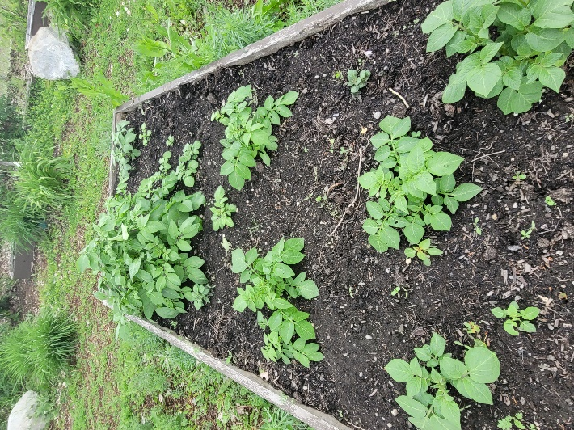
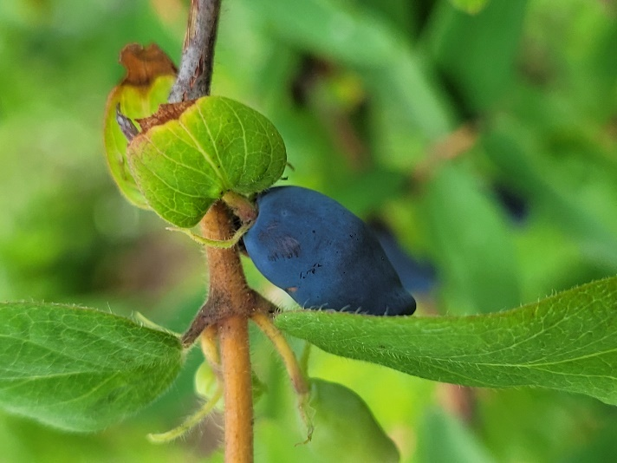
FIRST DAYS OF SCHOOL

Just a reminder to families that the first few days of school in the fall are exceptionally fluid for us in the office with new registrations, etc. For that reason, we will keep students in grade-alike groups and students will not be assigned homerooms immediately. I will likely send out a list of students in classes in the evening that week (much like what I did last fall) once we have confirmed classes. You need to know that we are working furiously those first couple of days to sort things out and our goal will be that by the end of the week, students are settled.


Parent Advisory Council (PAC):
This Photo by Unknown Author is licensed under CC BY-NC

We have an amazing group of parents that support our school each and every day. A special thank you to our 2021-2022 team of Samantha Mitchell, Arla Bruce, Savala Rose Axell, Daila Duford, Dréa Duford, and to our representative trustee Amanda Krebs. We say a fond farewell to Daila Duford and Sam Mitchell this year, as their children are off to middle school. Thank you for your contribution. This year, we’ve engaged in important work, having reviewed our South Broadview Constitution, have supported some exceptional projects in the last year (the FM systems for classrooms) as well as several other endeavours. We so gratefully appreciate your help here at the school.

Our executive consists of the following people for 2022-23.
Arla Bruce PAC president
Savala Rose Axell PAC treasurer
Dréa Duford PAC Hot Lunch role next year
Mahalia Meeuwsen: PAC secretary and member(s) at large

Our first PAC meeting will happen (likely at the school) on Monday Sept. 12 at 7:00pm. Please feel free to contact us in the office if you’d like to take part!



MyEducation BC Family Portal
Thank you to those of you who have signed up for the MyEd Family portal.
This is an important place for all families to become acquainted with and to register with. As we move into the next school year, we will rely less on paper copies of documents and more on web-based services. You can expect to have all report cards start to be published on the family portal. Additionally, the important forms and releases that we request at the beginning of the school year are found on the family portal. I’d like to strongly encourage families over the summer to sign up for this service before the next school year begins. If you lose instructions, you will find the link on our right side of our website. It will remain there.
If you create your username and login, you will notice that you are able to retrieve your child’s Term 3 report card. As we move ahead with this system, this will become the main transmission of reporting information. You can find this information on our website under the ‘parents’ tab and along the right side of our page.

MyEd Family Portal

We have opened the MyEducation BC Family Portal. This access will allow you to see grades, attendance, and other information on your child(ren). Each parent or guardian will have their own separate account.
Login accounts are created for parents/guardians who have parental authority and have provided an email address to the school. The username and temporary password will be sent to the email address on file.
Link to login to MyEducation BC Family Portal
https://myeducation.gov.bc.ca/aspen/logon.do
- Your username is your email address on file.
- You will receive an email from sysadmin@myeducation.gov.bc.ca when your account has been created with your temporary login password. Please check your junk mailbox if you have not received an email.
- Pop-ups must be enabled for certain features of the site to work properly.
- When logging in for the first time, you will be prompted to change your password and establish a security question. It is important to remember your security question as it will allow you to recover your password if you forget it.
This link will step you through the login process and provide you with FAQ’s.
Family Portal Instructions & FAQ
If you require further assistance, please email MyEdSupport@sd83.bc.ca or call (250) 804-7846.

Criminal Records Checks:

Did you know that the process for ensuring you can volunteer in the school has become far more simplified and FREE? We’d love to invite you as volunteers into the school, to help us with all sorts of things, from reading with children to helping out with events. CR checks are now good for several years, so we’d love to encourage you to start the process so that you’re ready to jump in and support the school when you want to next year.

In order to get a Criminal records check, please follow the following link with password:

https://justice.gov.bc.ca/criminalrecordcheck
Access Code: 6TQTFUJGQP

This process takes 3 wks – a month to process, so if you do it right away, then you’ll be ready to roll for the fall. Thanks for thinking of doing this. We need your help!!

Traversa Ride 360

To parents of BUS Students: we are excited to be onboarding a transportation APP that allows you a variety of options regarding your child’s bus ride, from knowing the schedule (and if the bus is running late), to communicating with the bus driver if your child is not on the bus.
This is a feature for school district buses only (and not daycare busses).
Please see the attached document to fully explain this new service for bus students.

